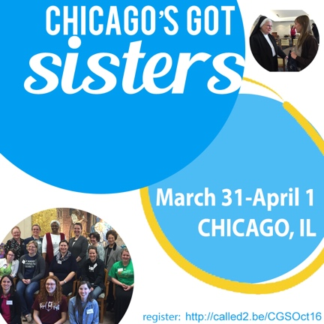
Chicago’s Got Sisters! | March 31-April 1 | Chicago, IL

Spend 24 hours visiting and praying with sisters from a variety of religious communities. Come experience community life, while asking questions about discernment and getting answers in real time. For single Catholic women ages 18-40. For more information, contact Sister Theresa Sullivan, D.C., at sistertheresa.sullivan@doc.org or 812-963-7556. Register now online at http://called2.be/CGSMar17

