CELEBRATION OF RELIGIOUS BROTHERS DAY
MAY 1st
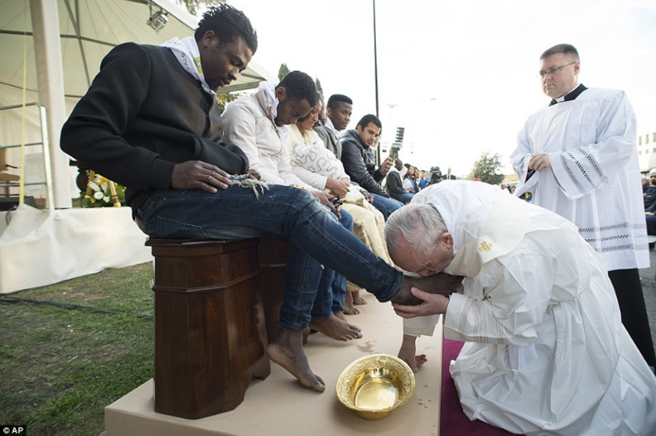
Making Jesus Alive In our World
We are All Brothers!

Call to Ponder

Document: “Identity and Mission of the Religious Brother in the Church”
“Rooting his life deeply in God, the Brother consecrates all creation, recognizing the presence of God and the Spirit’s action in creation, in cultures and in daily events, Because the Brother recognizes this active presence, he can proclaim it to his contemporaries. This ability is the fruit of an ongoing process of openness to God through consecration, that is, through the daily experience of his baptismal priesthood. Through the gift of Brotherhood given, he becomes a bridge between God and his brothers, anointed and sent by the Spirit to bring the Good News of the love and mercy of God to all, especially to the least of his brothers, the weakest members of humanity.”

Call to Prayer

All: Jesus the Christ,
You became our brother, shared our flesh and blood and shared in solidarity with the human sufferings of your brothers and sisters!

Leader: Jesus the Christ,
You gave us, your disciples, the honor of being
called “Brother” after your Resurrection and so we are!

All: Jesus the Christ,
You are our Good Shepherd and our Good Samaritan,
As we journey into the future, may we, Brothers,
be reflections of your great love and compassion for all your people.

Opening Hymn (You Tube)
Brothers and Sisters in Christ Terry Dittmer Arr. By Craig Alea
Sing Alleluia! Amen!
Let your prayers and your praises ascend.
Lift up your voices and sing to our Lord God, our Savior and King!
Here brought together by grace, we are gathered as friends in this place.
Chorus
And assembled as one, in the name of the Son,
lifting hearts, lifting hands, celebrating as friends,
and proclaiming the Lord, all our praises afford.
We are brothers and sisters in Christ.
Man walked alone and in need,
without faith, hope or promise or creed;
wandering aimlessly lost; unaware of the staggering cost;
that God in his mercy would save all his people from death and the grave.
Chorus
Lord, teach us how to proclaim
all your goodness, your love and your name!
Lord, teach us how to forgive, and in love, teach us Lord, how to live.
Raising our voices in song, help us tell all the world we belong.
Chorus
Call to Listen to God’s Word

Isaiah 42:1-7 The Servant of God
Here is my servant whom I uphold, my chosen one with whom I am pleased.
Upon him I have put my spirit; he shall bring forth justice to the nations.
He will not cry out, nor shout, nor make his voice heard in the street.

A bruised reed he will not break, and a dimly burning wick he will not quench.
He will faithfully bring forth justice. He will not grow dim or be bruised
until he establishes justice on the earth; the coastlands will wait for his teaching.

Thus says God, who created the heavens and stretched them out, who spread out the earth and its produce,
Who gives breath to its people and spirit to those who walk on it:

I, your God, have called you for justice, I have grasped you by the hand;
I formed you, and set you as a covenant for the people, a light for the nations,
To open the eyes of the blind, to bring out prisoners from confinement,
and from the dungeon, those who live in darkness.
The Word of God. All: Thanks be to God

Silent Time for Reflection

Call to Respond

Psalm 62 Psalms for Praying Nan C. Merrill

Antiphon: My soul thirsts for the living God.

For You alone my soul waits in silence;
From the Beloved comes my salvation.
Enfolding me with strength and steadfast love,
My faith shall remain firm….

In the Silence rests my freedom and my guidance, for
You are the Heart of my heart,
You speak to me in the Silence.

Trust in Love at all times, O people
Pour our your heart to the Beloved;
Let Silence be a refuge for you. …

Once You have spoken,
Twice have I heard;
Our potential gifts belong to You;
To You, O render to us all that we offer to You—
Fear begets fear,
Love begets love.
For You alone my soul waits in silence;
From the Beloved comes Life, Love and Light.

Glory to the father, the Son and the Holy Spirit, now and forever. Amen.

Antiphon: My soul thirsts for the living God!

Call to Intercession

Leader: The thread of abiding in the love of Jesus weaves through a Brother’s life and his presence in the world transmits that abiding thread of being sent as a sign of the maternal tenderness of God and the fraternal love of Jesus for all. Conscious of this mission, let us now offer our intercessions to our God.

- We pray that the witness of religious Brothers and Sisters in the Church may draw all persons to know, love and serve God in this world, we pray.
R: May we be great witnesses to God’s immense love for us, his brothers and sisters!

- We pray that he image of the Good Shepherd, like the image of Jesus wrapped in a towel washing the feet of his disciples, may speak to us of service, love and sacrifice, and may we Brothers be devoted to our mission of bring others to know this same Jesus, our Lord and Brother, we pray.
R: May we be great witnesses to God’s immense love for us, his brothers and sisters!

- For all religious Brothers and Sisters whom God has sent in the name of Jesus to serve the people in love and service that they will be blessed with continued faithfulness to Jesus and inspire many more to consider a
vocation to consecrated life, we pray.
R: May we be great witnesses to God’s immense love for us, his brothers and sisters!

- We pray God’s blessing on all religious Brothers who have devoted their lives to building up God’s Kingdom of love, peace and justice. We ask you to guide them, strengthen them, sustain them and shower them with your grace. May they always be close to you in prayer and reach out, in turn, to help their neighbors in need. We pray.
R: May we be great witnesses to God’s immense love for us, his brothers and sisters!

All:
God, Creator of Life,
May we be prophets in our time and place!
May we witness with our lives your openness and loving acceptance
of all creatures, your constant care and protection of life in all its forms.
May we give a great witness to that human search for a
deeper spirituality and a greater humanization of all society.
We ask this prayer in the name of Jesus, your Son and our brother. Amen.

Leader: Let us now raise our voice to our God in prayer as Jesus taught us!
Our Father

Call to Benediction

All:
“How beautiful on the mountains are the feet of those who bring good news, who proclaim peace, who bring good tidings, who proclaim salvation,
who say to Zion, “Your God reigns!” Is 52:7 May we, Brothers and Sisters in Jesus,
bring his Good News of healing love, compassion, joy and liberation
to all to whom we serve and minister. We ask our prayer in the Name of Jesus the Christ who lives forever and ever. Amen.

Closing Hymn: The Servant Song

Will you let me be your servant, Let me be as Christ to you
Pray that I might have the grace To let you be my servant too
We are pilgrims on the journey, We are brothers on the road
We are here to help each other, Walk the mile and bear the load
I will hold the Christ light for you, In the night time of your fear
I will hold my hand out to you, Speak the peace you long to hear.
I will weep when you are weeping, When you laugh, I’ll laugh with you
I will share your joy and sorrow, Till we’ve seen this journey through.
When we sing to God in heaven, We shall find such harmony
Born to all we’ve known together, Of Christ’s love and agony.

MAY JESUS ALWAYS LIVE IN OUR HEARTS – FOREVER!

