Name - Mayra Eva Melgar Lopez
(Sr Eva Melgar)
Congregation – Missionary Sisters of
St. Charles Borromeo Scalabrinians
How long in Vocation Ministry? 4 months

Birthplace: Oaxaca, Mexico

Favorite Pastime / Hobby: Making paper quilling

What book is currently on your bedside table?
My book of prayers is usually on my bedside table.

Do you cook? I like to prepare Mexican food like Tlayudas.

Favorite TV Show: I like to watch CNN News

Favorite Movie: My favorite movie is Shrek.

Favorite Song: My favorite song is Oceans (where feet may fail), Hillsong United

Favorite flavor of ice cream: Chocolate

Favorite Scripture quote: ``Behold I`m the handmaid of the Lord.`` Luke 1:38

I’ve always wanted to visit: Egypt

My favorite thing about being a religious Sister: To have the opportunity to meet people and be part of their lives.

I receive the most joy from: I received the most joy from my grandmother.

Why be a religious today: Because there are many challenges in society.

What are you passionate about? My passionate is hiking and reaching my goal.
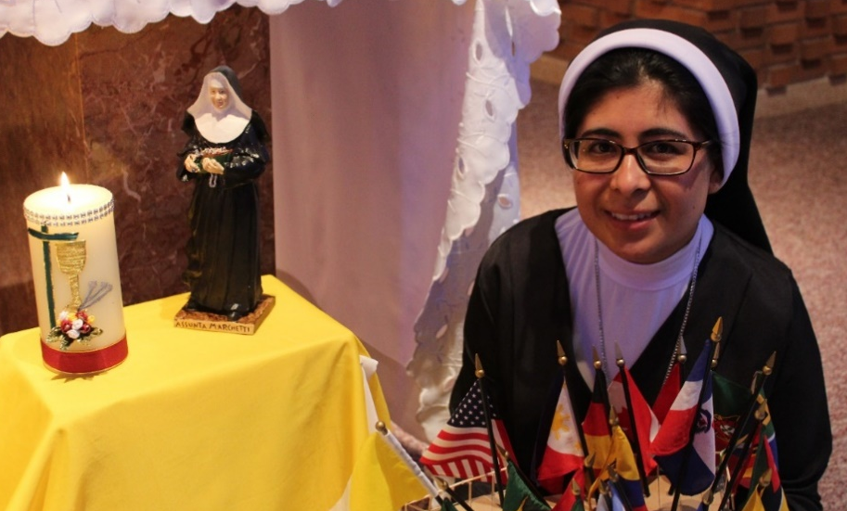
How do you relax? I`m relaxed looking at the garden and walking.

