May 2022 SURVEY – Area of interest
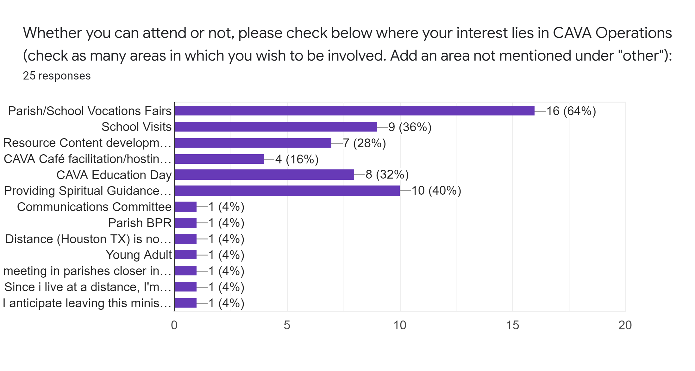

---------------------------------------------------------------------------------------------------------------------------------
1 Connie Bach
cbach@poorhandmaids.org
Parish/School Vocations Fairs,
School Visits,
Resource Content development (lesson plans, video clips, articles, photo submission, content for CAVA social media, reporting your community events),
CAVA Education Day,
Communications Committee
___________
2 Kathleen Branham
Kbranham@oldenburgosf.com
Parish/School Vocations Fairs- Already a part of it
___________
3 Maria Brizuela
maria.brizuela@fssh.net
Parish/School Vocations Fairs,
School Visits,
Providing Spiritual Guidance/Accompaniment in general (not just to discerners for your community)
___________
4 Mary Jo Curtsinger
Mjcurtsinger@csjoseph.org
Parish/School Vocations Fairs, School Visits, Resource Content development (lesson plans, video clips, articles, photo submission, content for CAVA social media, reporting your community events), CAVA Education Day
___________
5 Gregory Darr
gdarr@maryknoll.org
Parish/School Vocations Fairs, School Visits
___________
6 Michele Fisher
sorellamichele@aol.com
Resource Content development (lesson plans, video clips, articles, photo submission, content for CAVA social media, reporting your community events), CAVA Café facilitation/hosting (online and/or in person or both) - You will be provided support, CAVA Education Day, Providing Spiritual Guidance/Accompaniment in general (not just to discerners for your community),
Since i live at a distance, I'm happy to participate and assist with anything "virtual"...BPR's, school or parish visits, CGS, etc.
___________
7 Arturo Gonzalez
arturogonzalez3386@gmail.com
Parish/School Vocations Fairs
___________
8 Michelle Horton
MHORTON@sinsinawa.org
Young Adult
___________
9 Lisa Kane
lkane@racinedominicans.org
I anticipate leaving this ministry in August, 2022. My replacement has not been named.
___________
10 Adam MacDonald
adamsvd@yahoo.com
Parish/School Vocations Fairs, School Visits, Providing Spiritual Guidance/Accompaniment in general (not just to discerners for your community)
___________
11 Kathryn Madden
kathrynmadden@hotmail.com
Providing Spiritual Guidance/Accompaniment in general (not just to discerners for your community)
___________
12 JOAN MARY
JMary@adriandominicans.org
CAVA Café facilitation/hosting (online and/or in person or both) - You will be provided support
___________
13 Dan Masterton
dmasterton@viatorians.com
Parish/School Vocations Fairs, School Visits, Resource Content development (lesson plans, video clips, articles, photo submission, content for CAVA social media, reporting your community events), CAVA Education Day, Providing Spiritual Guidance/Accompaniment in general (not just to discerners for your community)
___________
14 James McDonald
bromaccfc@yahoo.com
Providing Spiritual Guidance/Accompaniment in general (not just to discerners for your community)
___________
15 Mayra Eva Melgar Lopez
mayeeva231@gmail.com
Parish/School Vocations Fairs, Resource Content development (lesson plans, video clips, articles, photo submission, content for CAVA social media, reporting your community events), CAVA Café facilitation/hosting (online and/or in person or both) - You will be provided support, CAVA Education Day, Providing Spiritual Guidance/Accompaniment in general (not just to discerners for your community)
___________
16 Lovina Pammit
lpammit@archchicago.org
Parish/School Vocations Fairs, School Visits, Resource Content development (lesson plans, video clips, articles, photo submission, content for CAVA social media, reporting your community events), CAVA Café facilitation/hosting (online and/or in person or both) - You will be provided support, CAVA Education Day, Providing Spiritual Guidance/Accompaniment in general (not just to discerners for your community), Parish BPR
___________
Until May 25!17 Fr. Victor Patricio, OMI
vpatriciosilva@omiusa.org
Parish/School Vocations Fairs, Providing Spiritual Guidance/Accompaniment in general (not just to discerners for your community)
___________
18 Suzanne Petrouski
spetrouski@lcmh.org
Resource Content development (lesson plans, video clips, articles, photo submission, content for CAVA social media, reporting your community events)
___________
19 Michael Scherschel
mscherschel@sainthubert.org
Parish/School Vocations Fairs
___________
20 Fr. John Schork, CP
jschork@passionist.org
Distance (Houston TX) is now a major challenge for my involvement.
I gladly share my limited experience and am grateful for other's experience.
___________
Thanks for encouraging growth and support in this important ministry.21 Stephanie Thompson
stephanie.thompson@sndden.org
CAVA Education Day, Providing Spiritual Guidance/Accompaniment in general (not just to discerners for your community)
___________
Thanks22 Skolastika Wea
skolastika@ssps-us.org
Parish/School Vocations Fairs, School Visits, CAVA Education Day
___________
23 Sr. Denise Glazik, OP
dglazik@spdom.org
Parish/School Vocations Fairs, meeting in parishes closer in the diocese
___________
24 Gloria Tamayo
gtamayomm@gmail.com
Parish/School Vocations Fairs, School Visits
___________
25 MaryLou Rajdl
rajdlmarylou@gmail.com
Parish/School Vocations Fairs
___________

